MUSEUM | LONDON

Lesson Plan – Art Car
Subject: Visual Art | Teacher:
Grade Level: JK/SK | Date:
Topic: Colour (Fun Car) | Timeframe:

Ontario Curriculum Expectation(s)
V1.1 – demonstrate an awareness of personal interests and a sense of accomplishment in visual arts
V2.1 – explore a variety of tools, materials, and processes of their own choice to create visual art forms in familiar and new ways
V2.2 – explore different elements of design in visual arts
V3.1 – use problem-solving skills and their imagination to create visual art forms

Learning Goal
Students will…
-be introduced to the concept of 3D sculpture
-explore colour, pattern, and texture
-use their imagination to create an interesting vehicle

Materials/ Resources
-egg cartons (cut into a range of sizes)
-acrylic/ craft paint
-scissors
-hot glue gun/ hot glue sticks
-other decorative materials on hand (sparkles, pompoms, toothpicks, etc.)
www.parentsociety.com

Differentiated Activities:
-Lego/large building blocks

Lesson
Introduction: (5-10 min.)
-students will be introduced to the reference artwork, “Car” by Greg Curnoe and discuss how they would react if they saw a vehicle like this one on the street
-Curnoe enjoyed making artwork that was personal, and this work was no exception, referencing the style of his own car
-invite students to brainstorm together what their car might look like if they could design one of their very own, in order to make it as interesting as possible!
Body: (30 min.)
-students will be provided with sections of an egg carton (approx. half a carton)
-they will move and reposition carton pieces in order to plan out the form of their car
-adults in the classroom will have hot glue stations set up in order to assist with the assembling of the vehicles
-when students’ car forms are glued together, paint and decorative materials will be provided for students to complete the design of their personal car
Conclusion: (10 min.)
-invite students to share their “art car” to the class and why they made it the way they did

Differentiation
Visually impaired students and students with impaired motor skills:
-students will be provided with Lego or large building blocks in order to create their “art car”

Assessment and Evaluation
Students’ work will be evaluated based on a checklist with the following criteria:
-made an unconventional vehicle with creative design
-incorporated at least 3 different colours/patterns
-was on task while working
-was able to share something about their “art car” either to the class at large or during an interview with teacher

Art Resources

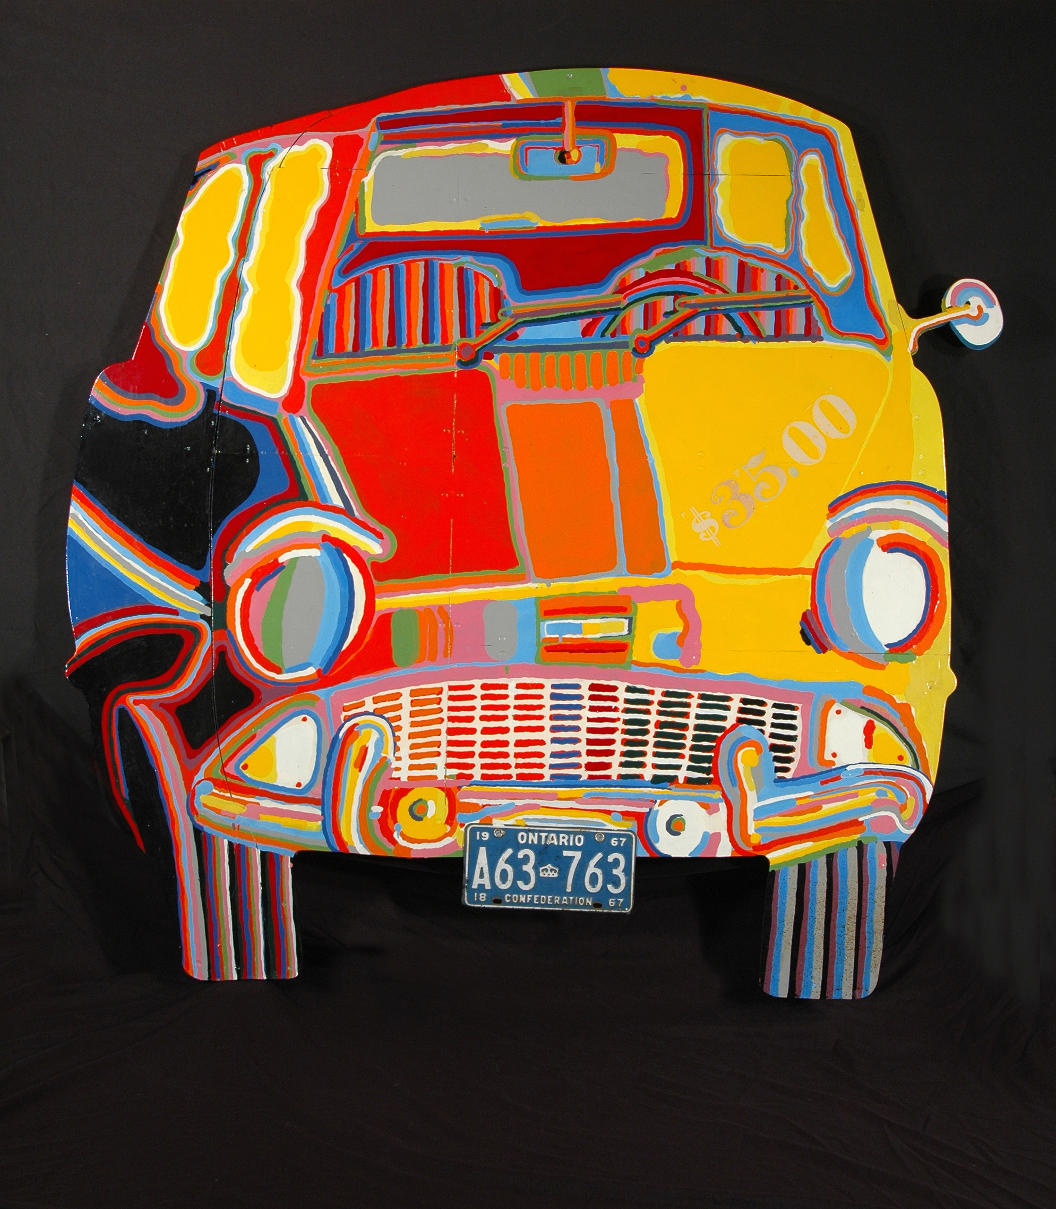
Car, Greg Curnoe, Oil, Metal, Masonite, Wood, 1967, 168 x 173cm
http://visiblestorage.ca/car/
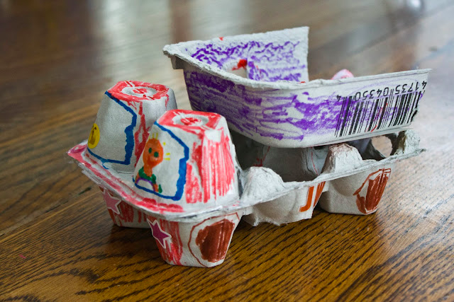
http://www.parentsociety.com/parenting/big-kids/11-car-and-truck-crafts-for-tiny-gearheads/

