Art/Social Studies: First Nations Plasticine Totem Poles Grade 6
Lesson developed by Keith Devries and Sarah Elminshawi, adapted from an activity by Jaqui DePace
What Will You Teach?
Expectation(s):
The Arts, Visual Arts
- create two-dimensional, three-dimensional, and multimedia art works that explore feelings, ideas, and issues from a variety of points of view
- demonstrate an understanding of composition, using selected principles of design to create narrative art works or art works on a theme or topic
- use a variety of materials, tools, techniques, and technologies to determine solutions to design challenges
- identify and describe some of the ways in which art forms and styles reflect the beliefs and traditions of a variety of communities, times, and places
Social Studies: Heritage and Citizenship
- describe the attitude to the environment of various First Nation groups and show how it affected their practices in daily life
- build models or draw and label various forms of maps, using cartographic symbols and a legend
Materials and/or Resources: an image of Emily Carr’s Kitwancool Poles, 1940
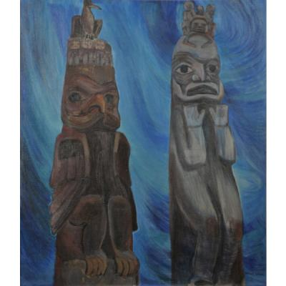
(this artwork can be accessed by going to the Museum London website http://museumlondon.ca/ and searching for it on the “collections” page – type in the title of the artwork Kitwancool Poles) for reference, brown plasticine, small, cylindrical tea containers, hot water in containers, various tools (plastic knives, forks, spoons, etc),
Important Terminology / Word Wall: colour, shape, movement, symmetrical balance,

How Will You Teach This? | Assessment for learning
Preamble: This lesson ties well into the Grade 6 Social Studies Heritage and Citizenship curriculum expectations. It is good for students to develop an understanding of the First Nations people in their own context prior to learning about them in the context of the Europeans to strengthen their appreciation of the various cultures. This lesson will fit well following a lesson focusing on totem poles and their significance. | Diagnostic:  A diagnostic portion can be done in relevant lessons leading up to this.
Lesson: Using the tea containers as an inner base, student will create their own totem pole sections. Upon completion they will all be stackable to create a complete totem pole. Students should all work in the same colour (preferably brown to represent the wood that totem poles were created with). Using a single colour ensures that the students to use the other elements of design to accomplish their desired composition.  Prior to the lesson, soak clumps of plasticine in warm water. This will increase the malleability of it and allow it to be more easily manipulated.  - Draw a plan. Have the students sketch out thumbnails for their sculpture. Encourage the students to create an image that has personal meaning. They should write a couple sentences about what their totem means to them. If there are large noses/wings/etc., a structure of popsicle sticks hot glued to the tea container may be required before beginning the next step.  - Students will flatten a piece of plasticine to go completely around the outside of the tea container (do not cover the top or bottom). Once the outside of the container is covered in plasticine, it is ready to have features added.  - Have them use various tools to develop and finish the totem, adding plasticine where necessary. | Formative:  As students experiment with the materials and develop their thumbnails, provide them with meaningful feedback to help them develop their work to its fullest potential.
Consolidation (reflecting, presenting, sharing, growing, adapting)  Note to teacher: it is suggested that the students provide some sort of artist statement to reflect on their work and meet certain expectations. This may come in the form of a written paragraph, oral presentation or other creative means. | Summative:  Students’ final compositions will reflect the knowledge and skills that they have gained throughout the lesson and in prior lessons. Assess the work in relation to how it meets the curriculum expectations.

