Grade: 4 Strand: Visual Arts Elements of Design: Colour, Shape and Form Principle of Design: Emphasis Length:
What Will You Teach?
Expectations
- D1.2 Demonstrate an understanding of composition, using principles of design to create a narrative artwork
- D1.4 Use a variety of materials, tools, and techniques to create a mixed media piece of art
- D2.1 Interpret a variety of art works and identify the feelings, issues, themes, and social concerns that they convey
- D2.3 Demonstrate awareness of the meaning of signs, symbols, and styles in works of art
- D3.1 Describe how visual art forms and styles represent various messages and contexts
Learning Goal
- I am learning to understand various art forms, styles, signs and symbols so that I can design and create a mixed media collage that represents a message to the audience
Success Criteria
- I can use a variety of materials
- I can identify emotions and themes in a piece of art
- I can design and create a piece of art that conveys a message to the audience
Materials and/or Resources
- Newsprint, acrylic paint (bold colours), foam shapes, buttons, paper plates, cardboard, found objects
- Images that showcase signs, symbols, and feelings (smiley face, use of dark colours)
- Magic Trash: Tyree Guyton
- Tyree Guyton
Polka Dot House
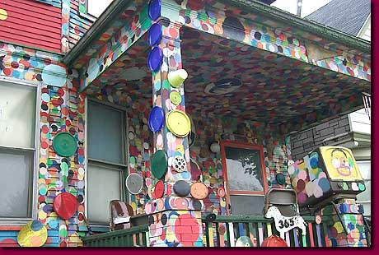
- Artwork from Museum London Visible Storage Collection (accessed through http://visiblestorage.ca/)
Car – Greg Curnoe
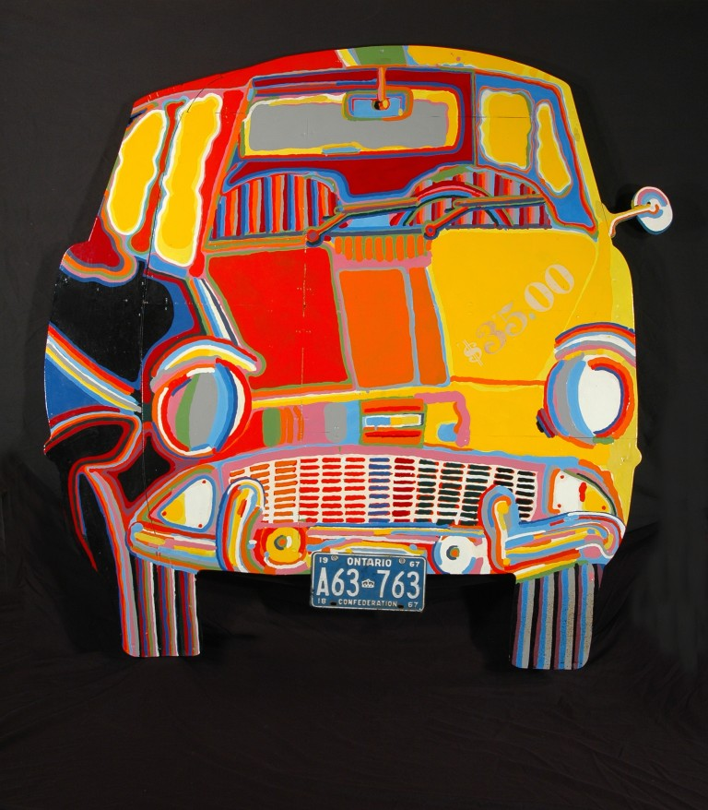
Important Terminology/Word Wall Words
- Emphasis, mixed media
How Will You Teach This?
Minds On!
Activate prior knowledge - showing the students various pictures of artwork that provoke feelings (happy, sad, angry, etc.). What techniques do the artists use to make us feel a certain way (i.e. colours: bright, warm, cool, dark)? Invite students to think about the issues and concerns of our world today (i.e. pollution, homelessness). It is our duty as responsible citizens to do our part in helping to create a caring community. Throughout the unit we will reflect on the role of an artist within his/her community. Show students images of everyday objects that artists have portrayed in a different manner than we would expect to see (i.e. Curnoe’s car: it is brightly coloured). Did he purchase this colourful car? Or was Curnoe trying to tell us a story about his car, by bringing it to life with bright colours? How do you think he felt about the car? What can we observe by looking at this car? What does it tell us about the artist himself?
Show the students a picture of an abandoned house. What do they see? Invite students to Think-Pair-Share and discuss the story behind the image. Ask for volunteers to share their observations. What about their feelings? How does it make them feel? Now show the students an image of one of the abandoned houses that Tyree Guyton has reimaged as an artist. What are their thoughts about this new photo? Does it offer hope? Is it just a mess of mixed items plastered on the outside walls of a building?
Read the story Magic Trash. Use the book as a gateway to learning about the ability to change perspectives and make connections about how some artists are called to “paint the world” just like we are expected to make a better world for ourselves and others.

Lesson Overview  Cementing the Knowledge  - Begin with a discussion on “what is the role of visual arts in our own community? Is there a difference between the role of the artist and the role of the audience?”  - Show the students a picture of an abandoned house. What do they see? Invite students to Think-Pair-Share and discuss the story behind the image. Ask for volunteers to share their observations. What about their feelings? How does it make them feel?  - Show the students an image of one of the abandoned houses that Tyree Guyton has reimaged as an artist. What are their thoughts about this new photo? Does it offer hope? Is it just a mess of mixed items plastered on the outside walls of a building? Reflect on the inspirational artist, Tyree Guyton, who has dedicated his life to the Heidelberg Project: an outdoor art project in Detroit, Michigan.  Critical Analysis Project (Artist study is possible here)  Students will find an image of an everyday object (car, building, bicycle, etc.) and recreate the image, which will change the perception of how the audience will view the object. This activity will encourage students to examine each other’s work through the creative process by following the steps: initial reaction, description, analysis and interpretation, expression of an informed point of view, and consideration of cultural context. | Task & Assessment
- Observe student understanding and making anecdotal notes

- Success criteria
- Was the artwork successful in translating the message to the audience? Observe how students discuss their own work and the work of their peers (focus on the strengths)
- Provide descriptive feedback
Consolidation  The Beautiful Project  Show materials you have brought to class and allow students to bring in their own additions. Allow time for students to experiment with these items to recreate a piece of art that uses elements of design (colour, shape and form) and resemble one of the techniques used by the artists we have explored throughout the unit. Challenge them to use one of the concepts of shape/form and express an idea about recycling or the natural world. Using the creative process, students will begin with an inspiration and accept the challenge to work towards developing a final product that will be evaluated and reflected upon. Once the projects are complete, engage students in an artist talk about their own work. Ask for volunteers to begin the non-judgmental artist talk. During their talk, students will discuss the materials they used, why they chose those materials, and explain how they implemented elements of design. Gather together as a whole group and revisit the discussion about the role of the artist and the role of the audience in communicating a message within a work of art. | - Culminating Task – 1 page reflection that explains the work (similar to the artist talk)

