Lesson Plan Information
Subject: Science and Art | Name:
Grade: Three | Date: | Time:
Topic: Relating Science and Technology to Society and the Environment | Period Length:

Expectations
Curriculum Expectations (Based on the Ontario Curriculum Documents):
1.1 assess ways in which plants are important to humans and other living things, taking different points of view into consideration (e.g., the point of view of home builders, gardeners, nursery owners, vegetarians), and suggest ways in which humans can protect plants
1.2 assess the impact of different human activities on plants, and list personal actions they can engage in to minimize harmful effects and enhance good effects
Learning Skills (Where necessary):

Content
What learners will know/be able to do:
Students will be able to identify the benefits of various plants and how humans use plants. Students will be able to brainstorm ideas about how to protect plant life, and will have learned why preservation of plants is necessary.
Today learners will:

Assessment and Evaluation
Determining student understanding:
Students will create a collage of natural resources like twigs, leaves and grass, small pebbles, etc. They will accompany it with a paragraph about the importance of plants. Student paragraphs will explain at least one benefit of plants, and one way to preserve plant life on the planet.

Perspective
Necessary Prior Knowledge:
Students do not need any prior knowledge, as this is an introductory activity to learning about the importance of plants to humans.
Differentiation:
Students with mobility issues may work with a friend to collect natural resources for their collage and have their friend help them glue.
Environment:
This lesson will take place in a classroom as well as outdoors in the schoolyard or a park to collect natural resources for the collage.
Resources/Materials:
Museum London Artworks:
(the following artworks can be accessed by going to the Museum London website http://museumlondon.ca/ and searching for them on the “collections” page – type in the names of the artists)
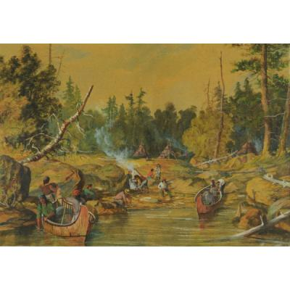
Lakeshore Encampment by William Armstrong, n.d.

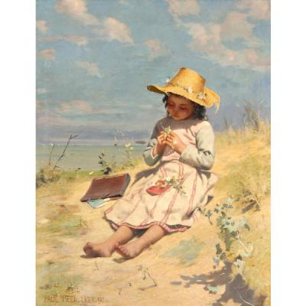
The Young Botanist by Paul Peel, 1888-1890

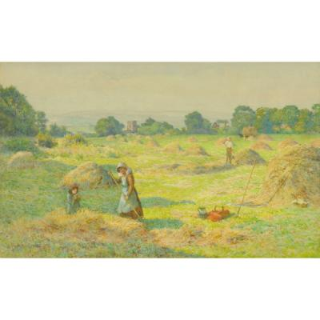
The Clover Harvest by J. Kirkpatrick, n.d.

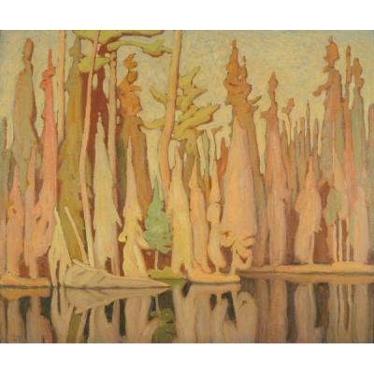
Northern Autumn by A.J. Casson, 1922

Construction Paper
Natural plant matter (leaves, bark, grasses, flowers, etc.)
White Glue
Scissors (if necessary)
Lined Paper
Pencil

Strategies
Introduction:
The teacher will ask students to think about what plants they would see in the woods, in the field, on a farm, and in a backyard. The teacher will ask students to discuss in small groups what plants do for people (ie. They provide food, medicine, lumber, paper, etc.)
Climax:
The teacher will display the artwork provided by Museum London and have students identify the various plants and plant products displayed in the art. Students will be asked to discuss why these plants are important to people. They will take part in a teacher-led discussion about some of the ways people harm, waste, or destroy plants, and learn about solutions to these problems (ie. Recycling paper products). Students will then go outside to a secure location with their teacher to collect plant materials: small twigs, grasses, flowers, leaves, etc. to glue onto construction paper to make a collage.
Conclusion:
Students will glue their plant matter onto construction paper to make a collage. Once finished, students will then write one paragraph to accompany their artwork (may be typed up and displayed with artwork). This paragraph will explain why humans use/need plants, and what we can do to protect plants and waste less.

