Lesson Plan Information
Subject: Social Studies and Art | Name:
Grade: Two | Date: | Time:
Topic: Relating Science and Technology to Society and the Environment | Period Length:

Expectations
Curriculum Expectations (Based on the Ontario Curriculum Documents):
1.1 identify positive and negative impacts that animals have on humans (society) and the environment, form an opinion about one of them, and suggest ways in which the impact can be minimized or enhanced
1.2 identify positive and negative impacts that different kinds of human activity have on animals and where they live (e.g., actions of animal lovers and groups that protect animals and their rights, the home owner who wants a nice lawn, people who visit zoos and wildlife parks, pet owners), form an opinion about one of them, and suggest ways in which the impact can be minimized or enhanced
Learning Skills (Where necessary):

Content
What learners will know/be able to do:
Students will learn to recognize the positive and negative impacts that animals have on humans and society. They will learn why protecting animals is important and how animals affect their daily lives. They will learn this through observing art from Museum London and reflecting on their own life experiences.
Today learners will:
Observe Museum London artwork and discuss how the animals represented impact people. They will suggest negative and positive impacts of these animals and why they are important to protect. Students will then draw a picture of any animal and write a positive and negative impact that that animal has on humans.

Assessment and Evaluation
Determining student understanding:
Students will display understanding by selecting an animal and successfully writing a positive and negative relationship it shares with humans.

Perspective
Necessary Prior Knowledge:
Students will have experience with animals whether having seen them in person, have seen them on television, or read about them in books to take part in the discussion.
Differentiation:
Students with limited motor skills may choose to cut and paste a photo of an animal from a magazine instead of drawing one, or they may print a photo off of the computer.
Environment:
Students will remain seated in their desks in a classroom, facing their teacher.
Resources/Materials:
Smart Board or overhead projector
Paper
Pencils
Pencil Crayons, Crayons or Markers

Museum London Artworks:
(the following artworks can be accessed by going to the Museum London website http://museumlondon.ca/ and searching for them on the “collections” page – type in the names of the artists)

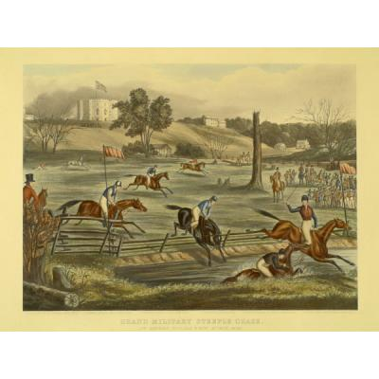
Grand Military Steeple Chase at London, Canada West, 9th May, 1843 by Lady Eveline Marie Alexander, 1845

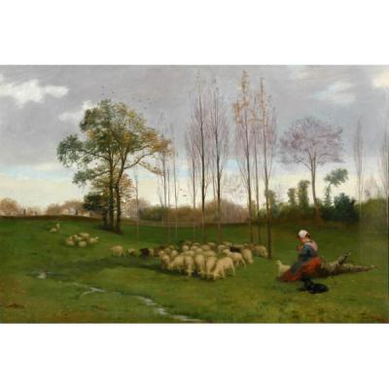
Return of the Flock by Paul Peel, 1883

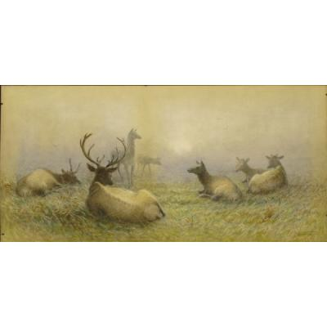
Elk Resting by Frederick Arthur Verner, 1891

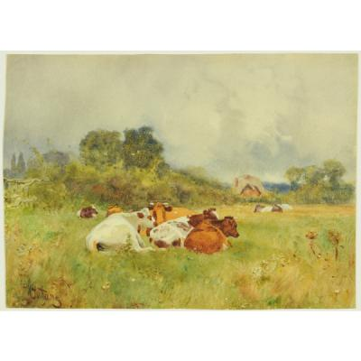
Cows in a Pasture by Walter Bothams, n.d.

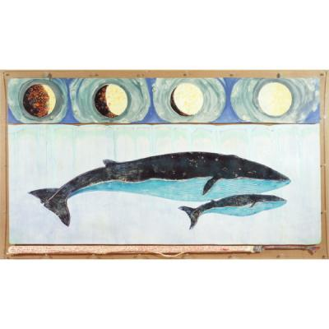
Mother Fin with Child by Tom Benner, 1982

Strategies
Introduction:
Teacher will have students brainstorm a variety of animals that they see throughout their lives (dogs, cats, birds, horses, cows, squirrels, mice, etc.). The teacher will ask students to identify how these animals positively or negatively affect human life and practices (Horses provide transportation, can plough fields, can provide entertainment, squirrels are fun to watch but also ruin gardens). Students will also identify how animals are important to one another (bugs are eaten by frogs which are eaten by fish, which are eaten by birds, when these animals die, bugs eat the animals).
Climax:
Display each picture provided by Museum London. Have students observe the animals depicted. Get students to discuss what purpose the animals depicted have to humans and/or other animals.
Conclusion:
Have the students draw a picture on standard white printer paper of any animal of their choice. Students will write the name of the animal at the top of the picture. Students will then write any positive and negative impacts that this animal has on humans at the bottom of the page. For example: If a student chose to do a cow, students would draw a picture of a cow, with the word “cow” at the top of the page. Underneath the picture, students would write that cows provide meat and milk products and manure for gardens, but that they produce a lot of bad waste (methane gas).

