Lesson Plan Information
Subject: Visual Arts | Name:
Grade: Two | Date: | Time:
Topic: Rhythm and Movement | Period Length:

Expectations
Curriculum Expectations (Based on the Ontario Curriculum Documents):
Visual Arts:
D2.1 Express their feelings and ideas about works of art (e.g., explain why they prefer a work by one artist over another; explain to a partner how well an art work reflects their personal knowledge and prior experience)
D2.2 Explain how elements and principles of design are used to communicate meaning or understanding in their own and others’ art work (e.g., use of different colours for achieving different effects, such as warm, sunny colours for a beach or cool colours for a wet forest; depiction of various textures, such as rough tree bark, smooth plastics, and ridged corduroy; elaboration and variation to create variety in otherwise symmetrical buildings)
D1.2 Demonstrate an understanding of composition, using principles of design to create narrative art works or art works on a theme or topic
Learning Skills (Where necessary):

Content
What learners will know/be able to do:
Students will be able to recognize and apply the elements of design as well as the principle rhythm and movement:
ELEMENTS OF DESIGN
Students will develop understanding of all elements of design.
• line: horizontal, vertical, diagonal lines; lines that show motion (e.g., pointy, curvy); lines inside shapes
• shape and form: symmetrical shapes and forms (e.g., shapes and forms in buildings)
• space: overlapping of objects to show depth
• colour: secondary colours (various colours made by mixing equal amounts of primary colours, such as violet, orange, green); mixing of colours with a limited palette
• texture: textures of familiar objects (e.g., rough tree bark, smooth plastic plate, ridged corduroy fabric); illusion of texture (e.g., a rough texture created by patterns of lines); impasto (thick, textured paint)
• value: mixing of a tint; identification of light and dark
PRINCIPLES OF DESIGN
Students will develop understanding of all principles of design (that is, contrast, repetition and rhythm, variety, emphasis, proportion, balance, unity and harmony, and movement), but the focus in Grade 2 will be on repetition and rhythm.
• repetition and rhythm: repetition of colour and shape in patterns; random, alternating, and regular patterns in everyday objects (e.g., textiles, ceramics) and in art (e.g., works by M. C. Escher)
Today learners will:
Create a multi-media picture representing either an underwater scene representing rhythm or a grassy scene using rhythm and movement. They will participate in class discussion about the artworks shown and how they incorporate rhythm and movement along with the elements of design and how they function in the artwork.

Assessment and Evaluation
Determining student understanding:
Students will demonstrate knowledge of rhythm and movement by completing artwork that will be marked on inclusion of rhythm and/or movement, along with completion and effort.

Perspective
Necessary Prior Knowledge:
Students will already know primary and secondary colours, and be familiar with the elements of design as well as the principle of contrast.
Differentiation:
Visual impairment: Student will instead listen to music and hold a pencil crayon to a sheet of paper and move their arm according to the rhythm, movement and mood they hear in the music. Their lines will be jagged and erratic for fast songs, and should show smooth lines to show calmer rhythm in music.
Impairment of Motor Skills: Student can use the Paint program on the computer to show a pattern using clip art and shapes. This will demonstrate rhythm. Encourage them to use one shape repeatedly with variation in size and colour.
Environment:
Classroom setting with access to an overhead projector or Smart Board
Resources/Materials:
Overhead projector or Smart Board
Construction paper (blue for water or green for grass; various colours for shapes)
Tissue paper (blue, green, purple for water or green, yellow, orange for grass)
Scissors
White Glue
Pencils

Museum London Artworks:
(the following artworks can be accessed by going to the Museum London website http://museumlondon.ca/ and searching for them on the “collections” page – type in the names of the artists)

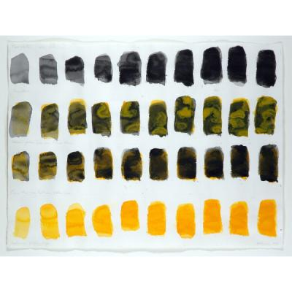
Test Pieces: Untitled and Test Pattern by Peter Kolisnyk, 1989

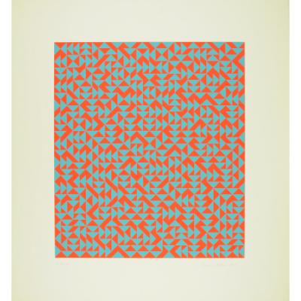
Untitled C by Anni Albers, 1969

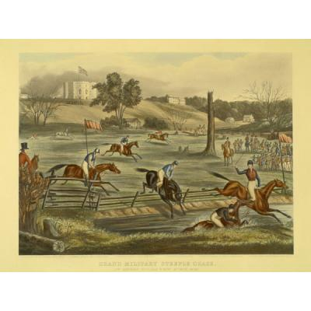
Grand Military Steeplechase at London, C.W. 9th May, 1843 by Eveline Marie Alexander, 1845

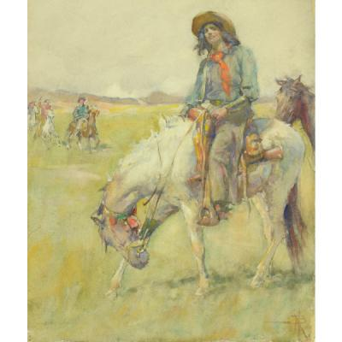
Cowboy on Horse by Nathaniel Hughes John Baird, n.d.

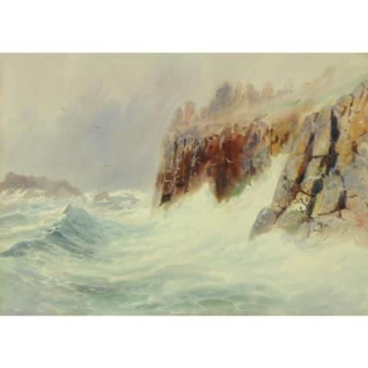
Rocky Coast by Frederic Marlett Bell-Smith, n.d.

Strategies
Introduction:
Ask students to explain what rhythm and movement is. How do they think it applies to art? Explain what rhythm and movement is when used in art. Rhythm, in art, is a visual beat. A pattern has rhythm, but not all rhythm is patterned. For example, the colors of a piece can convey rhythm, by making your eyes travel from one component to another. Lines can produce rhythm by implying movement. Forms, too, can cause rhythm by the ways in which they're placed one next to the other. Movement is the path the viewer’s eye takes through the artwork, often to a focal area. It can be directed along lines, edges, shapes and color. Movement is closely tied to rhythm.

Climax:
Show each picture listed under resources and discuss how it shows rhythm and/or movement. Ask how the rhythm and movement is created (i.e. repeated lines, similar objects of varied sizes, lines direct the eye, etc.) and ask them if it causes their eye to wander to a specific point on the artwork.
Conclusion:
Have students construct an underwater or grassy scene showing rhythm. They will choose either blue or green construction paper for the background and decide on a shape to repeat that belongs in either the green (grassy) background or blue (water) background. For example: Grassy backgrounds would go well with shapes like flowers, rabbits, trees, butterflies, dragonflies, etc., while water scenes would go well with fish, sharks, starfish, etc. Students can trace the shapes and cut them out using a variety of cardboard colours and paste them onto the construction paper (this creates rhythm through repetition of shape). Students will then use strips of tissue to glue along the bottom of the construction paper to represent seaweed or tall grass.

