Museum London– Grades 2 Lesson Plan
Teacher: My Nguyen
What Will You Teach?
Expectation(s): Strand: D1. Creating and Presenting- D1.2: “Demonstrate an understanding of composition, using principles of design to create narrative art works or at works on a theme or topic.”D1.3 “Use elements of design in art works to communicate ideas, messages, and understandings.”
Learning Goal: Students will be creating a landscape that tells story through the use of the elements of design, such as colours and lines.

Materials and/or Resources:
Watercolour paper, watercolour or tempera or acrylic paints, oil pastels or wax crayons
Important Terminology / Word Wall:
Colours, lines, emotions, movement, landscape, story telling

How Will You Teach This? | Assessment for learning
Minds On!  Using either the smart board or flash cards of colours, ask students how they feel when they look at different colours and to make connections to the real world. E.g. red= mad, heart, blood, etc. Display different types of lines and ask students what directions the lines are making their eyes go? E.g. vertical lines= up and down, horizontal lines= side-to-side, wavy lines= make your eyes move up and down, etc.  This will be a quick exercise before the lesson to provide students with the knowledge of colours and lines when they create their landscape. | Diagnostic  Students should know the colour wheel and different types of lines.
Lesson Overview + Key Questions: 2- 40 minutes class time  - Introduce the assignment by reviewing the colour wheel with the students and talking about how colour can be used to convey emotions and lines can create movement and guide viewers’ eyes through the artwork.  - Show students these works of art:  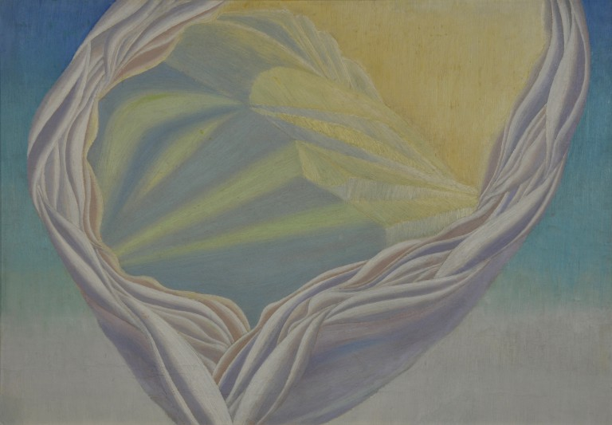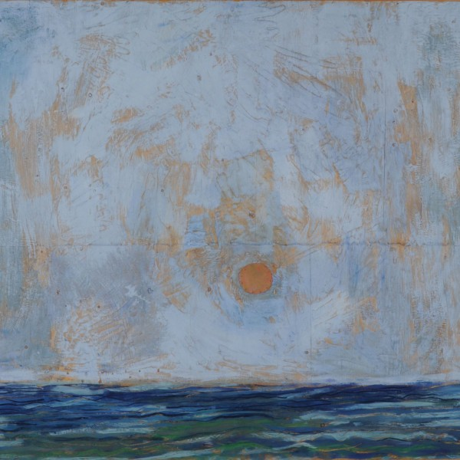  Abstraction, Music Sunset Over the  Mediterranean  by Bertram Brooker by Paterson Ewen  - These artworks display a variety of lines; diagonal, horizontal, wavy, etc. that show movement – they lead the viewer’s eyes through the works. The colours are natural and could be found in nature.  - For the lesson, students will create their own landscape with an emphasis on the use of lines and colours.  Step 1: Students will lightly draw their landscape with a pencil on watercolour paper and then go over the lines with crayons, using colours of their choice. This will help students stay within the lines when painting because the crayon will resist the paint and help students separate areas of deep colours.  Step 2: students will start painting - remind students to start off with the lightest colour and work their way to the darkest.  Step 3: Once students are done, they will place their landscape on their desk and as a class have a gallery walk to take a look at everyone’s artwork and the use of colours and lines.  Step 4: As a class, they will come together and reflect on the use of lines and colours, discussing how their classmates used them in their landscapes to capture a story. | Formative  - Students are demonstrating their understanding of primary colours and secondary colours.  - Students are demonstrating their ability to place colours side by side to create depth, contrast or emotions.  - Students are demonstrating their understanding of different uses of lines to create movement.
Consolidation  - Students will be given an opportunity to share with the class their landscapes and reflect on their use of colours and lines during the class gallery walk.  - The class will comment on each other’s artwork and discuss where each student has succeeded in achieving the goals of the lesson. | Summative  - Assessing students’ understanding and use of colours and lines in their landscape to tell a story.

