Lesson Plan Information
Subject: Science and Technology integrated with Art | Name:
Grade: One | Date: | Time:
Topic: Understanding Earth and Space Systems: Seasons | Period Length:

Expectations
Curriculum Expectations (Based on the Ontario Curriculum Documents):
Science:
  - Assess the impact of daily and seasonal changes on human outdoor activities and identify innovations that allow for some of these activities to take place indoors out of season.
  - Assess ways in which daily and seasonal changes have an impact on society and the environment
Learning Skills (Where necessary):

Content
What learners will know/be able to do:
Students will be able to identify how seasons are cycles, and how each season affects the plants, animals, and people as the weather changes. Students will be able to recognize each season represented in each work of art.
Today learners will:
Learn about Canadian seasons and participate in class discussions about their own experiences with seasons. Students will examine artwork representing all four seasons and identify what season is represented and why. Students will then draw or paint a picture of their favourite season.

Assessment and Evaluation
Determining student understanding:
Students will demonstrate understanding by participating in class discussion in which the teacher will take anecdotal records noting student participation. Students will then complete a picture of a season and be marked using a checklist that looks for accuracy (does a winter scene clearly represent winter - is there snow - no leaves on trees, etc.), as well as completeness, and effort.

Perspective
Necessary Prior Knowledge:
Students will already know the names of the seasons and basic associations with each. (Fall is cool and the leaves change colour, Winter is cold and has ice and snow, Spring is warm and has buds and new leaves and lots of rain, Summer is hot and dry and has flowers.)
Differentiation:
Visual Impairment: Focus on other senses (What does winter feel like? - cool, wet - taste like? - hot chocolate, peppermint - smell like? - pine, cinnamon). Have student describe their favourite season and why it is their favourite either orally to class or to the teacher instead of drawing a picture.
Impaired Motor Skills: Have student make a picture on the Paint program on the computer, or copy and paste photos from the computer or a magazine to create a collage of a season instead of drawing a photo.
Environment:
Classroom setting, projector or SmartBoard to show artwork from Museum London
Resources/Materials:
White Paper
Pencils
Crayons/Paints/Pencil Crayons
Overhead Projector or SmartBoard

Museum London Artworks:
(the following artworks can be accessed by going to the Museum London website http://museumlondon.ca/ and searching for them on the “collections” page – type in the names of the artists)

Fall Artwork:
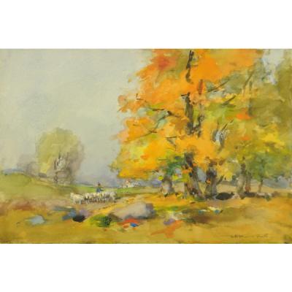
Autumn Landscape with Sheep by William “St. Thomas” Smith, n.d.
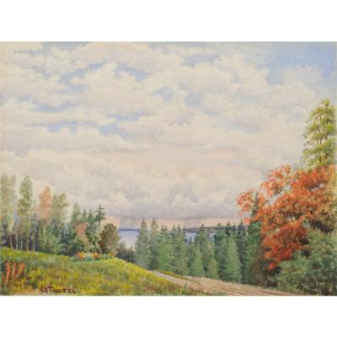
Autumn Landscape by Robert Le Touzel, n.d.

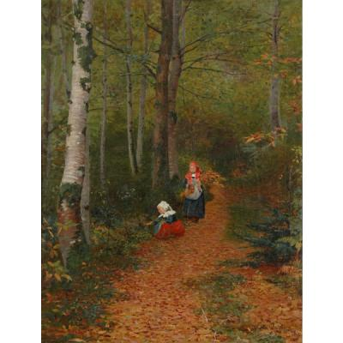
Autumn Leaves by Paul Peel, 1881

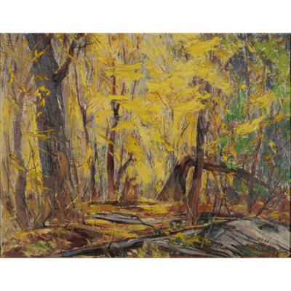
Autumn Woodland by Joseph Sydney-Hallam, n.d.

Winter Artwork:
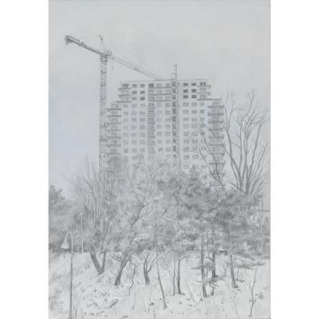
2008, Early Winter, Looking East Across Thames River by Bernice Vincent, 2008
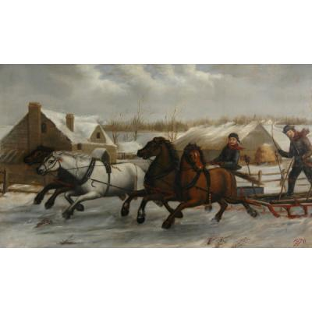
A Canadian Winter Scene by Paul Peel, 1877

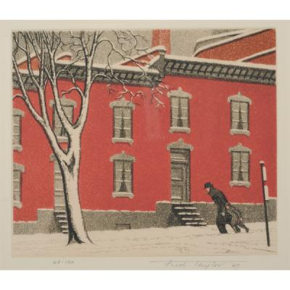
Early Winter, St. Urbain Street, Montreal by Fred Taylor, 1947

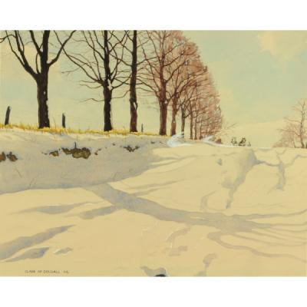
January Drift by Clark McDougall, 1944

Spring Artwork:

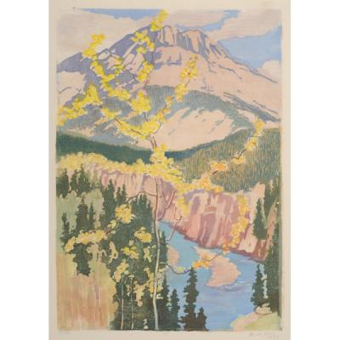
Coast Range, Spring by Bessie Symons, 1947

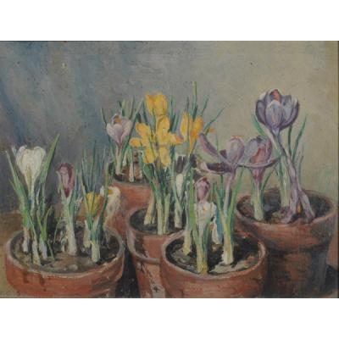
Spring Crocuses in Pot by Kate Taylor Cumming, c.1945

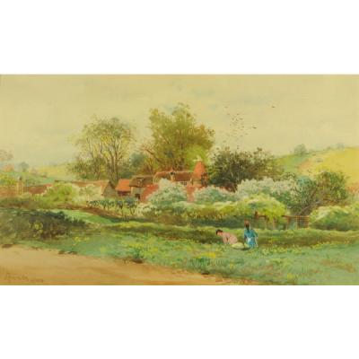
Spring in the Hop Country, Trugghurst, Kent, England by John Arthur Fraser, c.1888

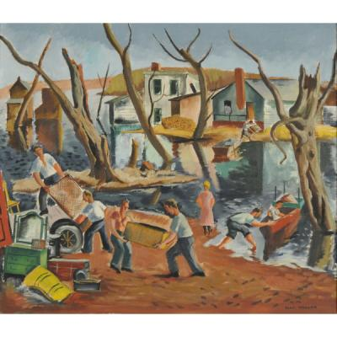
Spring Flood by Henri Masson, 1937
Summer Artwork:

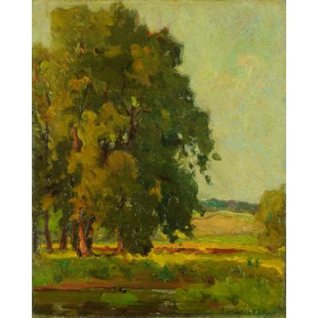
Summer Landscape by John William Beatty, n.d.

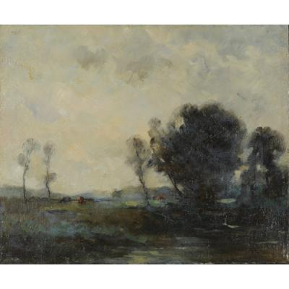
Summer Landscape by Edouard Chappel, n.d.

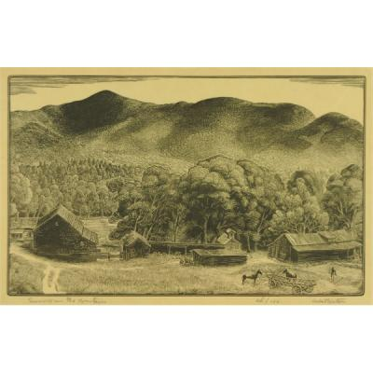
Summer in the Mountains by Herbert Waters, n.d.

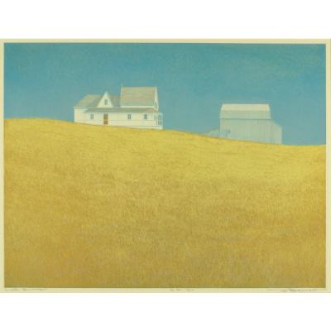
Late Summer by Tib Beament, n.d.

Strategies
Introduction:
Ask students what season it is. Have students discuss the differences between fall, winter, spring, and summer. Pay special attention to weather changes, changes to plants and animals, and how people cope or change their routines according to season changes.
Climax:
Explain how the seasons are a cycle and display the artworks listed under resources to the students and ask them to identify the season in each artwork and why we know it is that season.
Conclusion:
Have students draw a picture of their favourite season showing what that season looks like (ie. if it is representing spring, have flowers, a sun, rain, etc)

